DataPopEU Conference
Aristotle University of Thessaloniki
7-8 December 2022

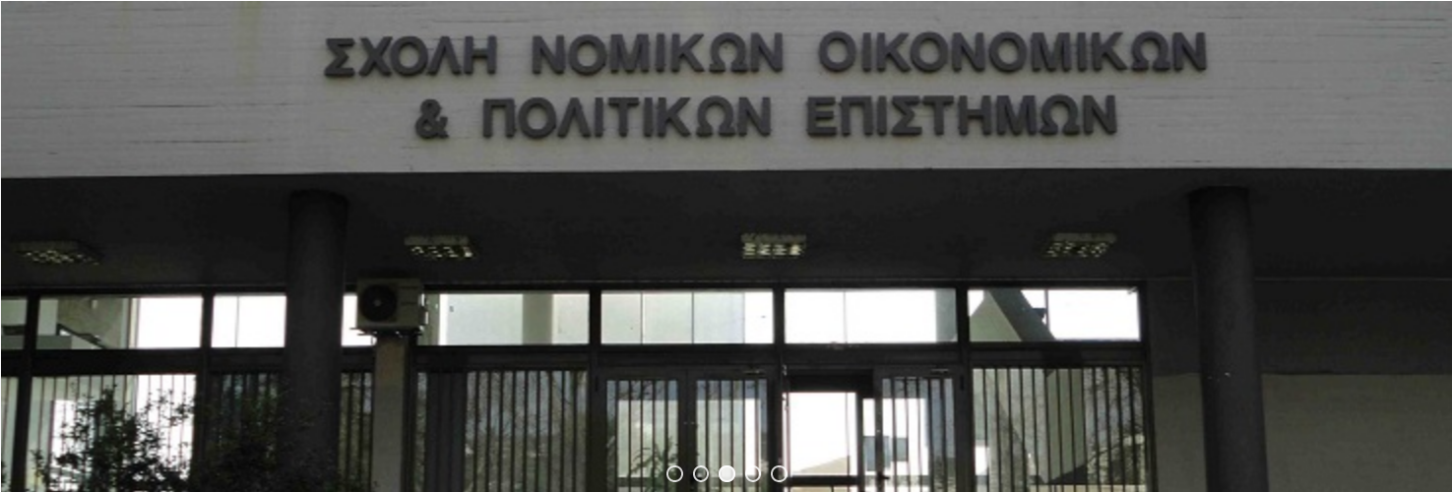
7 December 2022
School of Political Sciences, Aristotle University ,
Room 319 (for invited participants)

16:00 - 16:30: Welcome
16:30 - 17:15: COST Action on Populism, Euroscepticism
17:15-18:00 Horizon Europe WP 2023-2024
20:00 Dinner for the participants of the meeting

8 December 2022
Aristotle University
Research Dissemination Center (KEDEA),
Conference Hall 2

10:00 - 10:30: Welcome
10:30 - 12:00: Introduction, Opening and Panel 1 Data Science for Populism and Euroscepticism Research
Chair: Eftichia Teperoglou

Computer-based Methods for Populism Research
Presenter: George Makris

Automated Text Analysis of Eurosceptic Publications
Presenter: Paschalis Tsiombanis

New Methods in Data Collection and Data Cleaning
Presenter: Ioannis Andreadis

12:00 - 12:30: Coffee Break
12:30 - 14:00: Panel 2 Euroscepticism and Populism inside and outside Europe
Chair: Ioannis Andreadis

Euroscepticism in the Greek Press in the years 2020-2021. Discursive Patterns and Methodological Reflections
Presenter: Thomas Siomos

Trust towards the EU during the pandemic: a multilevel analysis
Presenter: Eftichia Teperoglou

Do populists in power influence civic culture? Evidence from Central and Eastern Europe
Presenter: Denis Ivanov

The populist radical right in Latin America and their connections with European populism
Presenter: Cristobal Alonso Sandoval Rojo

14:00 – 15:30: Lunch Break
15:30 - 17:00: Panel 3 Populism and Euroscepticism. Theory and Empirical Research
Chair: Eftichia Teperoglou

Exploring Congruence on Left/Right and Populism Dimensions
Presenter: Evangelia Kartsounidou

Contemporary Populism Research: Challenges and New Directions
Presenter: Yannis Stavrakakis

Populism as concept and phenomenon of international relations
Presenter: Angelos Chyssogelos

Studying the Correlation between Euroscepticism with Populism
Presenter: Ioannis Andreadis
17:00 - 17:30: Coffee Break
17:30 - 19:00: Round Table, Wrap-up, and Conclusions

20:00 Conference Dinner

